Software Requirements Specification
Version 3.0

Ambassadonia

Team <Team #4>
Member Name | Member Roll # | Primary Responsibility
Hasan Saleem | 15-4330
Hamza Rashid | 15-4280
Umer Riaz | 15-4152
Umair Zohiab | 15-4247

Appendix E: Test Cases
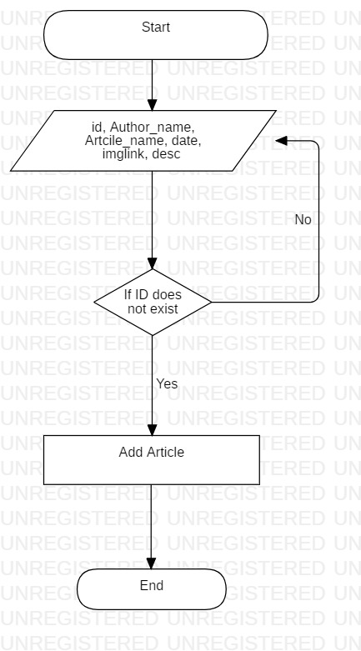
Branch Coverage:
Branches Covered/Total Branches = 2/2 = 100%

Path Coverage:
Paths Covered/Total Paths = 2/2 = 100%

Statement Coverage:
Statements Covered/Total Statements = 6/6 = 100%

Loop Boundary Testing:
No Loops

Identifier | TC-1
Priority | High
Related requirements(s) | <Include use-case identifier(s) for functional requirement(s) and SRS section/sub-section number(s) for other requirement(s).>
Short description | Admin can add an article
Pre-condition(s) | Admin should be logged in
Input data | id = 1  Author_name = Hamza  Artcile_name = How to program  date = 22/11/2018  imglink=www.google.com/images/programming.jpg  desc = Working in an industry I……………..
Detailed steps | 1. Enter the above details  2. Click the ‘Add Article’ button
Expected result(s) | Article will be added
Post-condition(s) | Article will be shown on the home page
Table 1: TC-1

Identifier | TC-2
Priority | High
Related requirements(s) | <Include use-case identifier(s) for functional requirement(s) and SRS section/sub-section number(s) for other requirement(s).>
Short description | Admin can add an article
Pre-condition(s) | Admin should be logged in
Input data | id = 1  Author_name = Hamza  Artcile_name = How to program  date = 22/11/2018  imglink=www.google.com/images/programming.jpg  desc = Working in an industry I……………..
Detailed steps | 1. Enter the above details  2. Click the ‘Add Article’ button
Expected result(s) | Article will not be added as ID is already added
Post-condition(s) | Article will not be shown on the home page
Table 2: TC-2
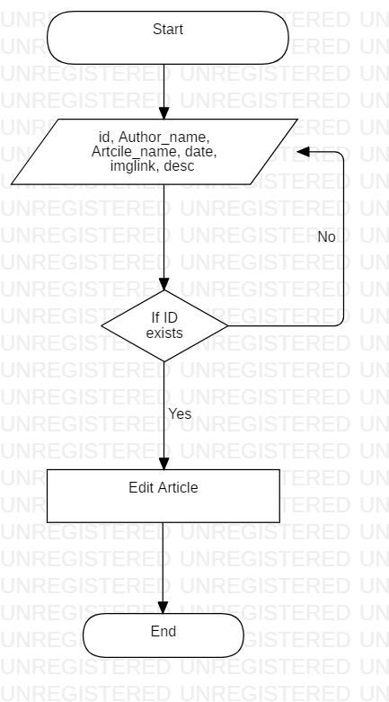
Branch Coverage:
Branches Covered/Total Branches = 2/2 = 100%

Path Coverage:
Paths Covered/Total Paths = 2/2 = 100%

Statement Coverage:
Statements Covered/Total Statements = 6/6 = 100%

Loop Boundary Testing:
No Loops
Identifier | TC-3
Priority | High
Related requirements(s) | <Include use-case identifier(s) for functional requirement(s) and SRS section/sub-section number(s) for other requirement(s).>
Short description | Admin can edit an article
Pre-condition(s) | Admin should be logged in
Input data | id = 1  Author_name = Hamza  Article_name = How to start programming  date = 22/11/2018  imglink=www.google.com/images/programming.jpg  desc = Working in an industry I……………..
Detailed steps | 1. Enter the above details  2. Click the ‘Edit Article’ button
Expected result(s) | Article will be updated
Post-condition(s) | Edited article will be shown on the home page
Table 3: TC-3

Identifier | TC-4
Priority | High
Related requirements(s) | <Include use-case identifier(s) for functional requirement(s) and SRS section/sub-section number(s) for other requirement(s).>
Short description | Admin can edit an article
Pre-condition(s) | Admin should be logged in
Input data | id = 3  Author_name = Hamza  Article_name = How to start programming  date = 22/11/2018  imglink=www.google.com/images/programming.jpg  desc = Working in an industry I……………..
Detailed steps | 1. Enter the above details  2. Click the ‘Edit Article’ button
Expected result(s) | Article will not be updated as ID does not exist
Post-condition(s) | Edit article page will show again
Table 4: TC-4
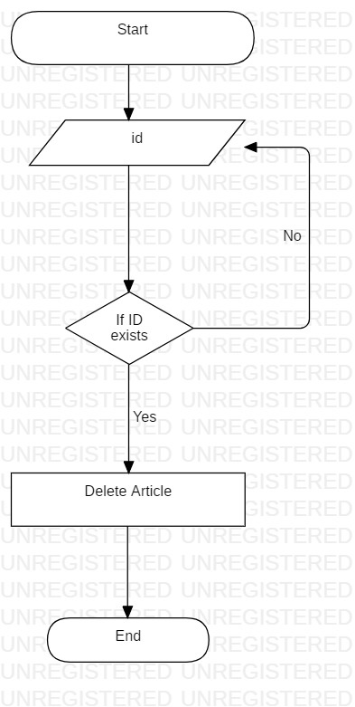
Branch Coverage:
Branches Covered/Total Branches = 2/2 = 100%

Path Coverage:
Paths Covered/Total Paths = 2/2 = 100%

Statement Coverage:
Statements Covered/Total Statements = 4/4 = 100%

Loop Boundary Testing:
No Loops

Identifier | TC-5
Priority | High
Related requirements(s) | <Include use-case identifier(s) for functional requirement(s) and SRS section/sub-section number(s) for other requirement(s).>
Short description | Admin can delete an article
Pre-condition(s) | Admin should be logged in
Input data | id = 1
Detailed steps | 1. Enter the ID of the article  2. Click the ‘Delete Article’ button
Expected result(s) | Article will be deleted
Post-condition(s) | Updated article home page will be shown
Table 5: TC-5

Identifier | TC-6
Priority | High
Related requirements(s) | <Include use-case identifier(s) for functional requirement(s) and SRS section/sub-section number(s) for other requirement(s).>
Short description | Admin can delete an article
Pre-condition(s) | Admin should be logged in
Input data | id = 3
Detailed steps | 1. Enter the ID of the article  2. Click the ‘Delete Article’ button
Expected result(s) | Article will not be deleted as ID does not exist
Post-condition(s) | Delete article page will be shown again
Table 6: TC-6
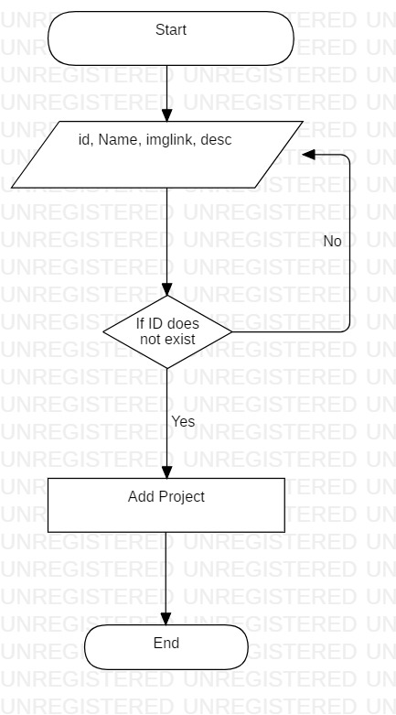
Branch Coverage:
Branches Covered/Total Branches = 2/2 = 100%

Path Coverage:
Paths Covered/Total Paths = 2/2 = 100%

Statement Coverage:
Statements Covered/Total Statements = 6/6 = 100%

Loop Boundary Testing:
No Loops

Identifier | TC-7
Priority | High
Related requirements(s) | <Include use-case identifier(s) for functional requirement(s) and SRS section/sub-section number(s) for other requirement(s).>
Short description | Admin can add a student project
Pre-condition(s) | Admin should be logged in
Input data | id = 1  name = Space invader  imglink=www.google.com/images/spaceship.jpg  desc = Working in an industry I……………..
Detailed steps | 1. Enter the above details  2. Click the ‘Add Student Project’ button
Expected result(s) | Student Project will be added
Post-condition(s) | Student Project will be shown on the home page
Table 7: TC-7

Identifier | TC-8
Priority | High
Related requirements(s) | <Include use-case identifier(s) for functional requirement(s) and SRS section/sub-section number(s) for other requirement(s).>
Short description | Admin can add a Student Project
Pre-condition(s) | Admin should be logged in
Input data | id = 1  name = Space Invader  imglink=www.google.com/images/Spaceship.jpg  desc = Working in an industry I……………..
Detailed steps | 1. Enter the above details  2. Click the ‘Add Student Project’ button
Expected result(s) | Student Project will not be added as ID is already added
Post-condition(s) | Student Project will not be shown on the home page
Table 8: TC-8
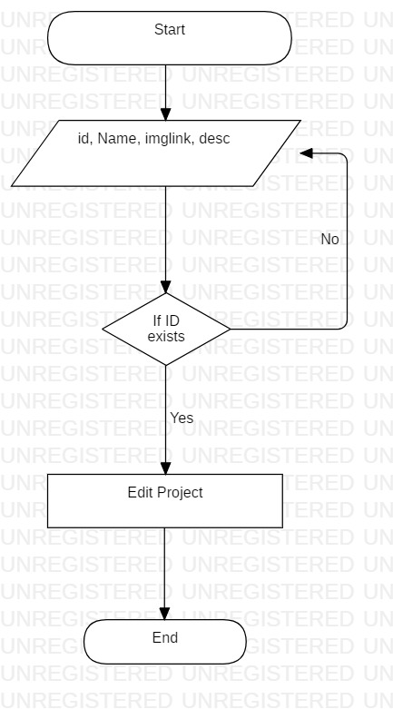
Branch Coverage:
Branches Covered/Total Branches = 2/2 = 100%

Path Coverage:
Paths Covered/Total Paths = 2/2 = 100%

Statement Coverage:
Statements Covered/Total Statements = 6/6 = 100%

Loop Boundary Testing:
No Loops

Identifier | TC-9
Priority | High
Related requirements(s) | <Include use-case identifier(s) for functional requirement(s) and SRS section/sub-section number(s) for other requirement(s).>
Short description | Admin can edit a Student Project
Pre-condition(s) | Admin should be logged in
Input data | id = 1  name = Space Invader  imglink=www.google.com/images/Spaceship.jpg  desc = Working in an industry I……………..
Detailed steps | 1. Enter the above details  2. Click the ‘Edit Student Project’ button
Expected result(s) | Student Project will be updated
Post-condition(s) | Edited Project will be shown on the home page
Table 9: TC-9

Identifier | TC-10
Priority | High
Related requirements(s) | <Include use-case identifier(s) for functional requirement(s) and SRS section/sub-section number(s) for other requirement(s).>
Short description | Admin can edit a Student Project
Pre-condition(s) | Admin should be logged in
Input data | id = 3  name = Space Invader  imglink=www.google.com/images/Spaceship.jpg  desc = Working in an industry I……………..
Detailed steps | 1. Enter the above details  2. Click the ‘Edit Student Project’ button
Expected result(s) | Student Project will not be updated as ID does not exist
Post-condition(s) | Edit student project page will show again
Table 10: TC-10
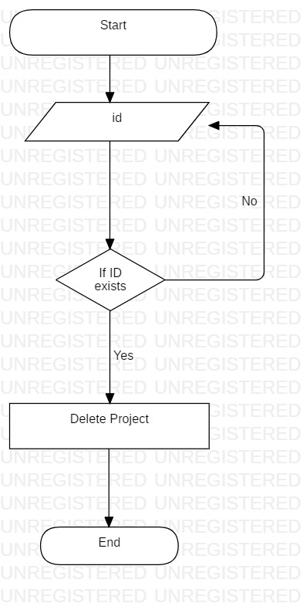
Branch Coverage:
Branches Covered/Total Branches = 2/2 = 100%

Path Coverage:
Paths Covered/Total Paths = 2/2 = 100%

Statement Coverage:
Statements Covered/Total Statements = 4/4 = 100%

Loop Boundary Testing:
No Loops

Identifier | TC-11
Priority | High
Related requirements(s) | <Include use-case identifier(s) for functional requirement(s) and SRS section/sub-section number(s) for other requirement(s).>
Short description | Admin can delete a Student Project
Pre-condition(s) | Admin should be logged in
Input data | id = 1
Detailed steps | 1. Enter the ID of the student project  2. Click the ‘Delete Student Project’ button
Expected result(s) | Student Project will be deleted
Post-condition(s) | Updated home page will be shown
Table 11: TC-11

Identifier | TC-12
Priority | High
Related requirements(s) | <Include use-case identifier(s) for functional requirement(s) and SRS section/sub-section number(s) for other requirement(s).>
Short description | Admin can delete a Student Project
Pre-condition(s) | Admin should be logged in
Input data | id = 3
Detailed steps | 1. Enter the ID of the student project  2. Click the ‘Delete student Project’ button
Expected result(s) | Student Project will not be deleted as ID does not exist
Post-condition(s) | Delete Student Project page will be shown again
Table 12: TC-12

